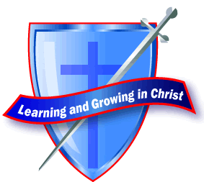
815 Sparrow Avenue
Lansing, MI 48910
Phone: (517) 482-1346
Fax: (517) 482-1313
St. Casimir Church
Faith Formation
Religious Education Program
K – Grade 8 YAC (Youth And Christ) Grade 9-12

Dear Parents/Guardians:

Here are the forms for the Religious Education program for this program year. We only require one registration form per family but we need a medical/permission form for each one of the children in your family. All information will be kept confidential but it is imperative we have medical info at our finger tips in case of a medical emergency. The Religion Teacher and Youth Minister will keep these forms in their student’s classroom for immediate access.

Please return completed registration and medical forms (along with your registration fee) to the Parish or Faith Formation Office. The registration fee remains the same $25, for one child, $50 for two children, all others in the family are free.

All classes meet on Sunday between the Masses from 10:10 to 11:20 AM. Grades K-8 meet in the parish classrooms, Confirmation Prep/YAC Youth Ministry program meets downstairs in the Parish Hall. Attached is the Faith Formation calendar. Please do NOT throw it away as you will need to refer to it throughout the program year.

Thank you for assisting your child/teen on their continuing faith journey. If you have any questions or concerns, please contact me at your earliest convenience.

God’s Peace….

Teresa Hurd Anthony Fisher
Faith Formation Director Coordinator of Youth Ministry
hurd@stcas.org fisher@stcas.org
517-482-1346 ex 307 517-482-1346

